**ABSTRACT**

**1. INTRODUCTION TO BLOOD DONOR MOBILE APPLICATION**

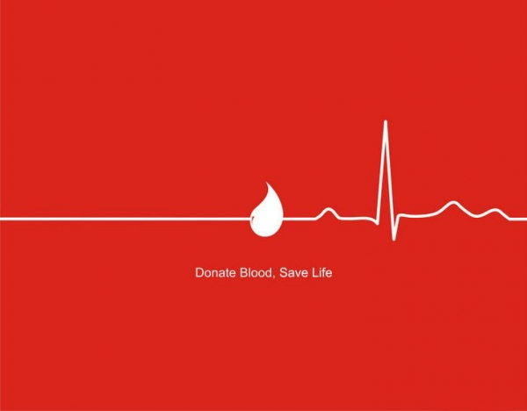

**1.1 About Blood Donor Application**

Blood Donor Mobile Application is built by keeping in mind the requirement of blood by million of Patients every day. Despite being a country with a population of 1.2 billion, India faces a blood shortage of 3 million units. The problem can be addressed if an additional two percent of Indians donated blood.

Facts about blood requirement :-

* Every year our nation requires about **4 Crore units** of blood, out of which only a meager **40 Lakh units** of blood are available.
* The **gift of blood** is the **gift of life**. There is no substitute for human blood.
* Every two seconds someone needs blood.
* More than 38,000 blood donations are needed every day.
* A total of 30 million blood components are transfused each year.
* The average red blood cell transfusion is approximately 3 pints.
* The blood type most often requested by hospitals is Type O.
* Sickle cell patients can require frequent blood transfusions throughout their lives.
* More than 1 million new people are diagnosed with cancer each year. Many of them will need blood, sometimes daily, during their chemotherapy treatment.
* A single car accident victim can require as many as 100 units of blood.

**1.2Number of Modules :-**

The project contains modules:-

* Module 1 – Registration.

The user is required to make one time registration to the application providing all the mandatory information such as his/her

* Name
* Phone Number
* Email Address
* Module 2 – This is the 2nd module where the Donar is to choose his blood group along with his State and city from the list and is required to fill the Area Code.
* Module 3 – The user will get all the information of near by Blood Banks and Blood Donation campaigns.
* Module 4 – Manage Appointments

The user can make appointments to the Donation Centers for donating blood and manage his Donation History.

* Module 5- Recruit Others

This will allow user to invite his friends and other contracts for donating blood.

* Module 6- SMS alerts

This will help user to get SMS alerts on his phone even when he/she is disconnected with the application.

* Module 7- First Aid Help and Emergency services

This will help user to get first aid help on the internet and make calls to emergency services.

**2. Objective :**

The main objective of developing such an application is to provide patients with a service on their mobile phones which will help them to find Blood Donar and also allows them to make an appointment to Donate blood to the nearby Blood Banks and find nearby Red Cross Blood drives.

It will also allow a user to get first aid help from the Internet and also allows user to invite their friend to join this noble cause.This application will also provide them to get First Aid and Emergency Help.

Using this application is quite simple and handy.It will help you managing schedules for donating blood, join or create a lifesaving team around your favourite organization.

**2.1 Abstract and Snapshots:**

This is to highlight the key feature of the project with snapshots for each activities are shown along with discussion of each activity describing its working.Each snapshot describes every single step of Blood Donar Application. The project is devide into many Activities which are further divide into Sub Activities which

is discussed below.Each activity has its own functioning which we will see as we move ahead with project.Some elements are still to be included in the project so we are goin to discuess them in brief and we will also try to improvise in each section,so might notice some changes in the final project then what is discussed here.

**2.2 Snapshots of outputs:**

**2.2.1Activity First: With Splash Screen.**

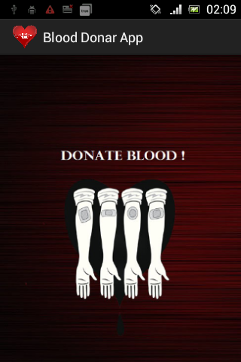

**Description:** This is the first activity or the first interface that the user will get on his screen when he launches the Blood Donar Application on his Mobile Phone.It will Display the image of the first activity along with logo of our mobile based aaplication. This Activity is made using Splash Screen which actually means is just provides user with interface for a couple of seconds then it moves to another activity on its own.

**Splash Activity:** Splash screen is generally used when there is a need to do some background process when an

application is initiated. Background process like loading the database, images, making a call over network. These kind of activities will consume time and a splash screen can be shown during that time. A splash screen can be the app icon, company logo and nice welcome image etcetera. Sometimes, splash screens are shown even when there is no need for a background process. This is just to showcase the brand through logo or some image and in this kind of promotional situations it is done based on fixed time interval.

**2.2.2Activity Second:**

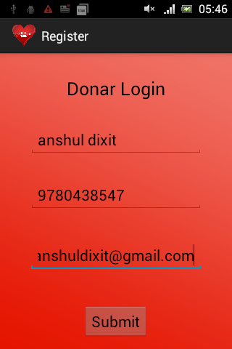

**Description :** This is our second activity which will be launched after Splash Activity terminates.This will be the

Second interface for user where he is required to fill all essential information needed for him to register to this Blood Donation application like:-

* His/Her full Name
* His/Her Phone Number
* His/Her Email Id

**Used Method and Elements :**

**Text View-**A **TextView**displays text to the user and optionally allows them to edit it. A TextView is a complete text editor, however the basic class is configured to not allow editing.

**Edit Text-**A EditText is an overlay over TextView that configures itself to be editable. It is the predefined subclass of TextView that includes rich editing capabilities.

**Button**- A standard Android button with text on is represented by the Android class android.widget.Button . You can insert a Button instance into your Android app GUI either via a layout XML file or via programmatic insertion. This tutorial will describe both methods.

**2.2.3ACTIVITY THIRD:**

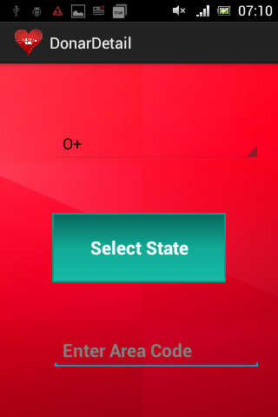

**Description:** This is third Activity to our Blood Donar Application project.In this the user is required to input some information regarding his Blood Group,Location and Area Code.He is needed to choose his blood group from a list of entities we have set using Spinner.Then he is required to select his Location but pressing Select Location Button which will lead him to yet another activity which will give him list of States along with cities in subview.The last thing he is required to do is Enter his Area Code.

**Spinner :** Spinners provide a quick way to select one value from a set. In the default state, a spinner shows its currently selected value. Touching the spinner displays a dropdown menu with all other available values, from which the user can select a new one.

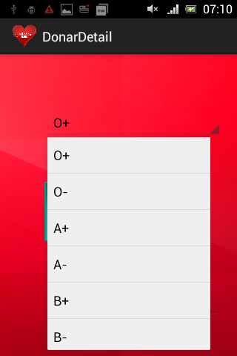

**List View :** Android **ListView** is a view which groups several items and display them in vertical scrollable list. The list items are automatically inserted to the list using an **Adapter** that pulls content from a source such as an array or database.

**Array Adapter :** An adapter actually bridges between UI components and the data source that fill data into UI Component. Adapter holds the data and send the data to adapter view, the view can takes the data from adapter view and shows the data on different views like as spinner, list view, grid view etc.

**2.2.4 Further Activities and their brief description:**

**ACTIVITY FOUR:** In this activity we will provide user with details of Blood Banks near his area,Blood donation campaigns date.

**ACTIVITY FIVE:** In this activity we will provide the user with SMS alert and to invite their friends to come hand in hand and support such a noble cause.We will use Content Provider n some of the WEB SERVICES and also Database.This will Also guide him with FIRST AID HELP and other emergency services.

**REFERENCES :**

1. Google.com
2. Tutorials point (www.tutorialspoint.com)
3. Java the complete reference by Herbert Schildt.
4. JavaTpoint(www.javatpoint.com)
5. Developers Android(www.Developer.Android.com)